Reverse Proxy
# Source: Chatgpt (GPT‑5 Mini) at [1/14/2026]
A Reverse Proxy is a server that sits between the internet (clients) and your backend servers, acting as an intermediary to manage incoming traffic.

🔁 Definition:
# Source: Chatgpt (GPT‑5 Mini) at [1/14/2026]
A Reverse Proxy accepts client requests on behalf of one or more backend servers, forwards them to the appropriate server, and then returns the server’s response to the client.

🧱 How It Works:
# Source: Chatgpt (GPT‑5 Mini) at [1/14/2026]
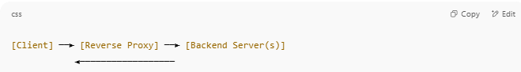
[Client] ──► [Reverse Proxy] ──► [Backend Server(s)]
◄──────────────────

- Client requests a web page (e.g., mywebsite.com).
- The Reverse Proxy receives the request first.
- It forwards the request to a backend server (like Server A).
- The backend server processes it and returns the result to the Reverse Proxy.
- The proxy returns the response to the client.

🎯 Common Uses of Reverse Proxy:
# Source: Chatgpt (GPT‑5 Mini) at [1/14/2026]
- Load Balancing: Distributes traffic across multiple servers to prevent overload.
- SSL Termination: Handles HTTPS encryption/decryption so backend servers don't have to.
- Caching: Stores frequent responses to reduce backend load.
- Web Acceleration: Speeds up responses using caching/compression.
- Security: Hides internal servers and blocks bad traffic.

🛡️ Benefits:
# Source: Chatgpt (GPT‑5 Mini) at [1/14/2026]
- Protects backend servers from direct exposure.
- Allows scaling (add more servers behind the proxy).
- Centralized SSL handling.
- Filters and monitors incoming traffic.

📌 Examples of Reverse Proxy Software:
# Source: Chatgpt (GPT‑5 Mini) at [1/14/2026]
- NGINX
- Apache HTTP Server (mod_proxy)
- HAProxy
- AWS Application Load Balancer
- Cloudflare (acts as reverse proxy for millions of sites)

🧠 Reverse Proxy vs Forward Proxy:
# Source: Chatgpt (GPT‑5 Mini) at [1/14/2026]
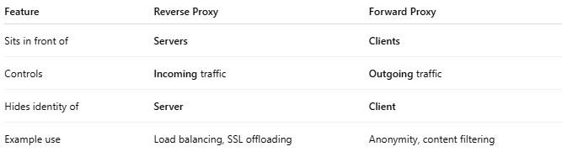
Feature | Reverse Proxy | Forward Proxy
Sits in front of | Servers | Clients
Controls | Incoming traffic | Outgoing traffic
Hides identity of | Server | Client
Example use | Load balancing, SSL offloading | Anonymity, content filtering

